
PA Project
Udemy finance analysis

October 11, 2026
Submitted By: Mr. HARSH SINGH
University Roll no.: 1240258188
Submitted To: Mr. DEEPAK SIR
PROJECT: (Predictive analytics)
- DATA LOADING AND PREPARATION:
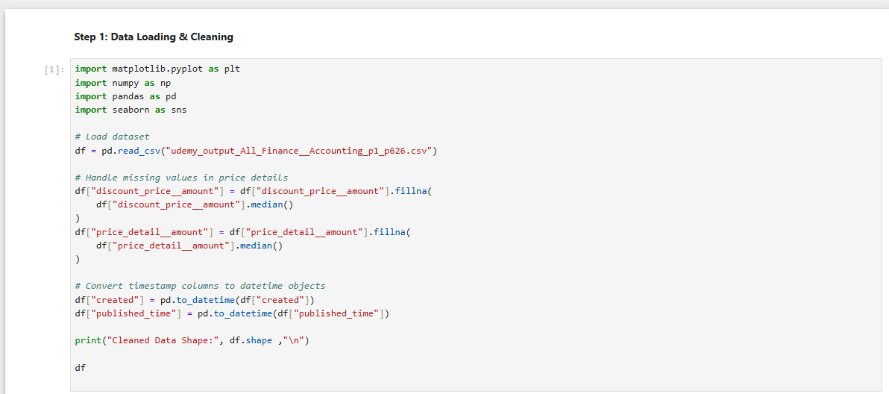
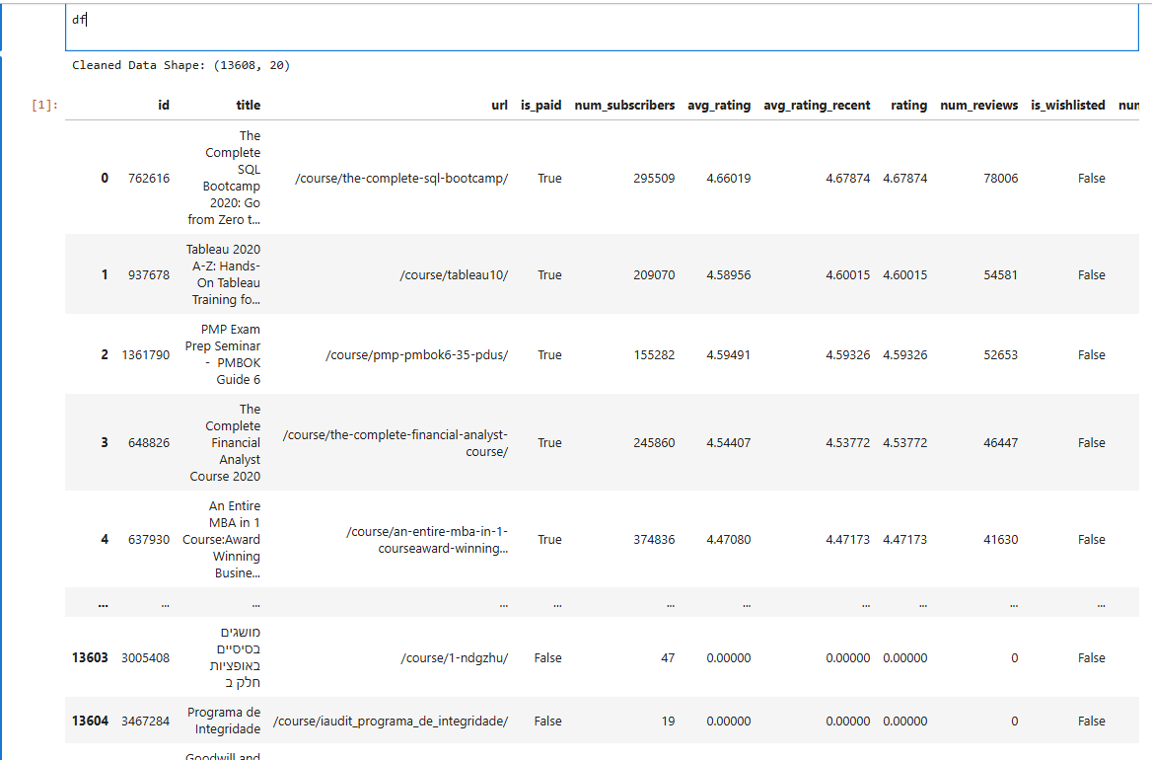

- FEATURE EXTRACTION:

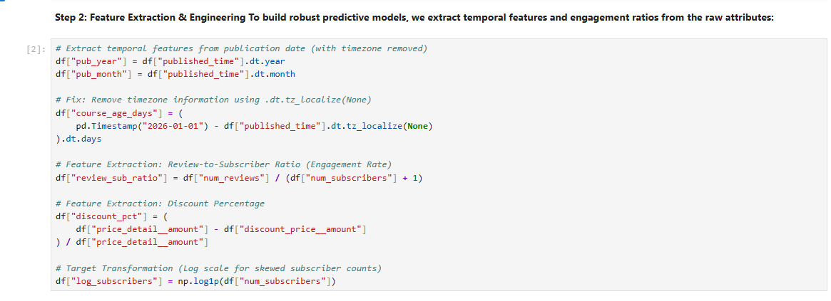

- EDA AND VISUALIZATION:

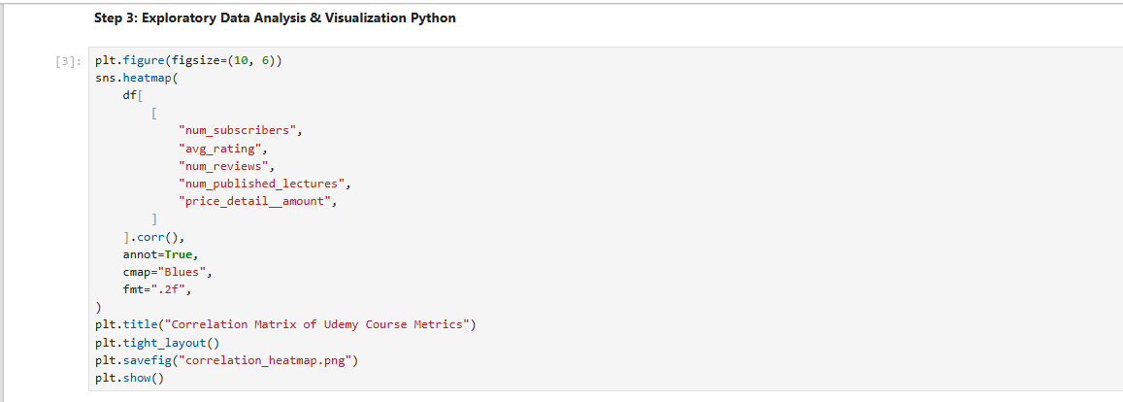
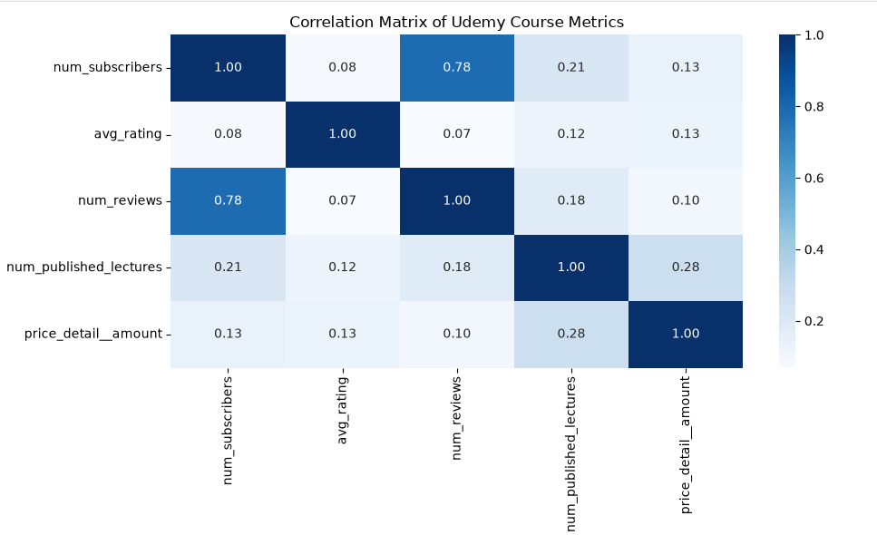
- ML MODELING AND EVALUATION:
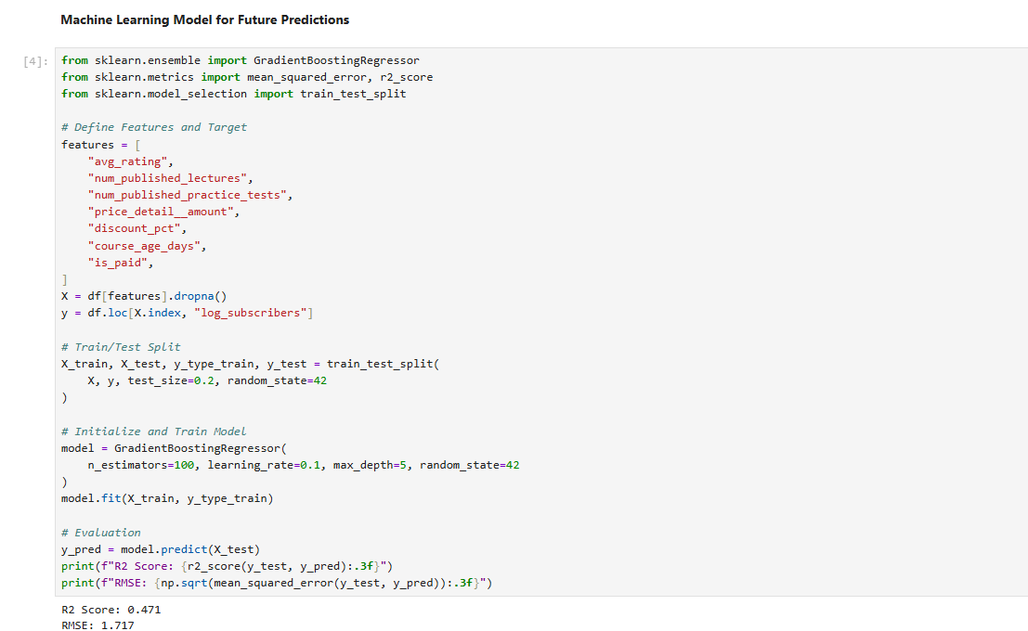

- Graphical Presentation & Model Interpretability:
